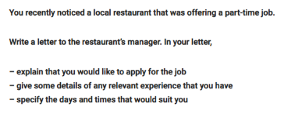

**Application Letter**

1. **Dear Sir/Madam,** (or name if given)
2. **Position – where advertised, when?**
   * **I would like to apply for the position of** nghề advertised in "Times" of January 19th, 2019 / "The Wings" issue of December 2018.
   * I am writing with regard to your advertisement published in the January's "Metro" / in yesterday's "Times" about the nghề position. **And I would like to apply for this job.**
   * **I am writing to you to express my interest in the** nghề **position** **as advertised** **on** Careerone.com.au. **And I would like to apply for this job.**
3. **Skills, diplomas, experience, personality**
   * **Age, qualifications, present job**
   * My name is ….
   * I am a (nghề hiện tại) with more than 10 years of experience in (lĩnh vực)
   * I am a recent graduate of the (tên trường) University and I have a significant background in (lĩnh vực)
   * I graduated from the University of Western Australia in 2016 with a degree in ...
   * **At present, I am employed as a nghề hiện tại by tên công ty**
   * **Experience**
   * **As you can see from my CV, I have … years of experience in lĩnh vực công việc**
   * I had one-year internship/apprenticeship with ... and the following 3 years ...
   * For the past two years I have worked as nghề / I was responsible for trách nhiệm công việc
   * **I believe I have a great deal of experience related to the vacancy because ……**
   * During my current profession/ job, I have …………
   * Dùng để kết phần kinh nghiệm: **And I strongly believe I can perfectly complete/ accomplish the job given/ the required tasks.**
   * **Skills and personal qualities**
   * **About my personality, I consider myself to be** reliable, hard-working and enthusiastic. Giải thích về tính cách cá nhân
   * I am used to working at a fast pace to meet deadlines.
4. **Why are you interested? Motivation, interview, references**
   * I would like to apply my skills in your company.
   * **I believe the position you offer will give me the opportunity to** ... **1**
   * **If you find my skills and experience suitable, please contact me to schedule an interview. 2**
   * I feel that my experience in sales makes me well suited for this position.
   * I consider myself a most suitable applicant for the job.
   * I have enclosed my references and resume.
   * I hope you will consider my application.
   * **I would be happy to send you references from my previous employers if you require them. 3**

Solutions and problems

According to the statistic/ reports, the obvious problems of the company are ….

I have done many researches in the field of ….. and I have finally figured out some problems that our company is facing ….

And if I am to be recruited/ accepted/ appointed with the position, I would …./ the feasible solutions I would carry out are……

1. **Formal ending, name, signature**
   * **I would appreciate a reply at your earliest convenience.**
   * **I look forward to meeting you to discuss the possibility of employment.**
   * Thank you for your time and consideration!
   * Yours sincerely, ... (you know the name of person you are writing to)
   * Yours faithfully, ... (you don't know the name!)

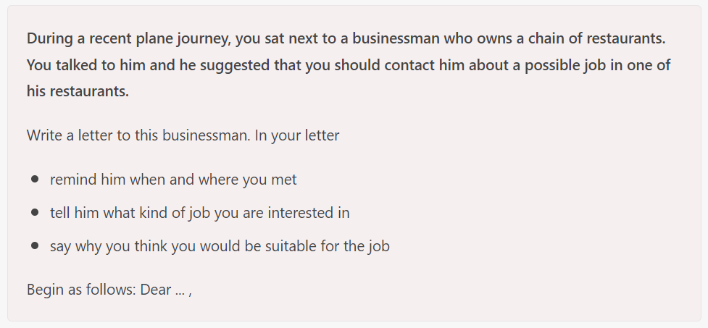



Dear Ms Trinh,

**My name is Hà, I had flight to Ho Chi Minh City two weeks ago and I sat next to you on the plane. I am writing to you to express my interest in the nghề position**. **And I would like to apply for this job.**

**At present, I am employed as a nghề hiện tại by tên công ty. As you can see from my CV, I have 10 years of experience in ….. And I strongly believe I can perfectly complete/ accomplish the job given/ the required tasks.**

**About my personality, I consider myself to be … Giải thích**

**I believe the position you offer will give me the opportunity to** **... If you find my skills and experience suitable, please contact me to schedule an interview. I would be happy to send you references from my previous employers if you require them.**

**I look forward to meeting you to discuss the possibility of employment.**

Yours faithfully,